Life Expectancy Dashboard[**Toggle navigation**](http://127.0.0.1:3816/)

Select Country

                                                                                                                                    Afghanistan

Afghanistan

Select Year Range2,0002,0152,0002,003.22,006.42,009.62,012.8

Alcohol Consumption vs Life Expectancy

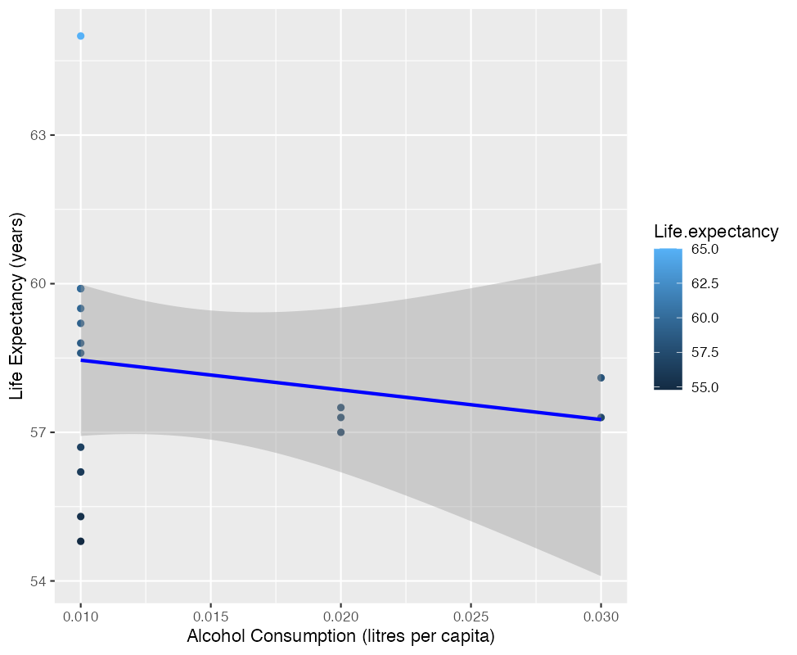

Health Expenditure vs Infant Deaths

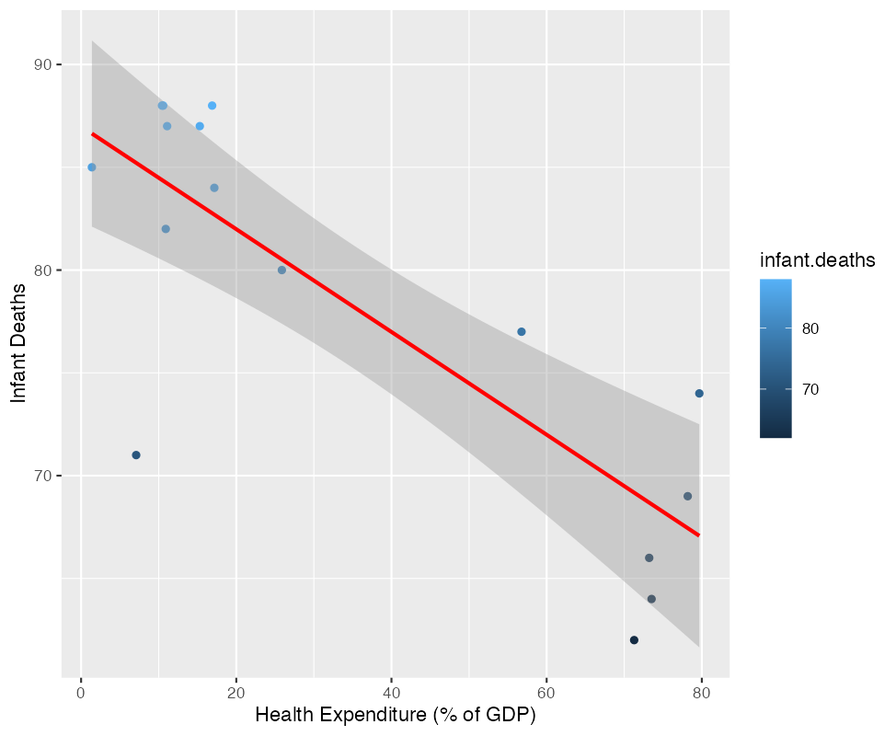

Hepatitis B vs Life Expectancy

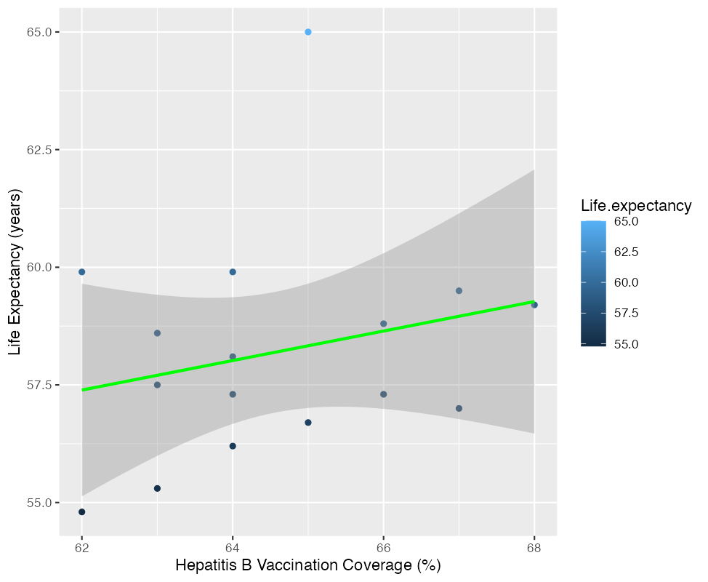

Polio vs Life Expectancy

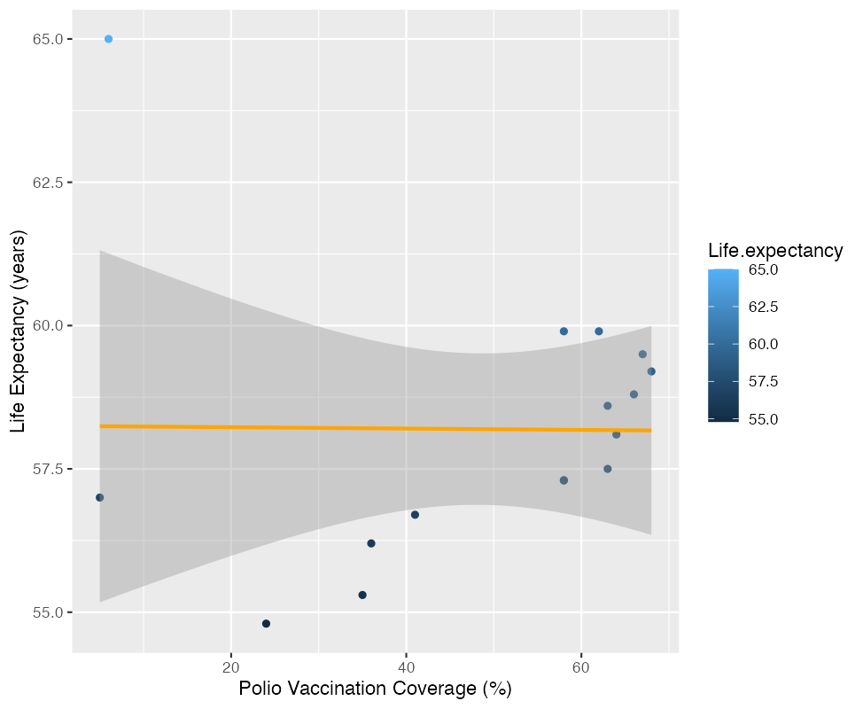

Diphtheria vs Life Expectancy

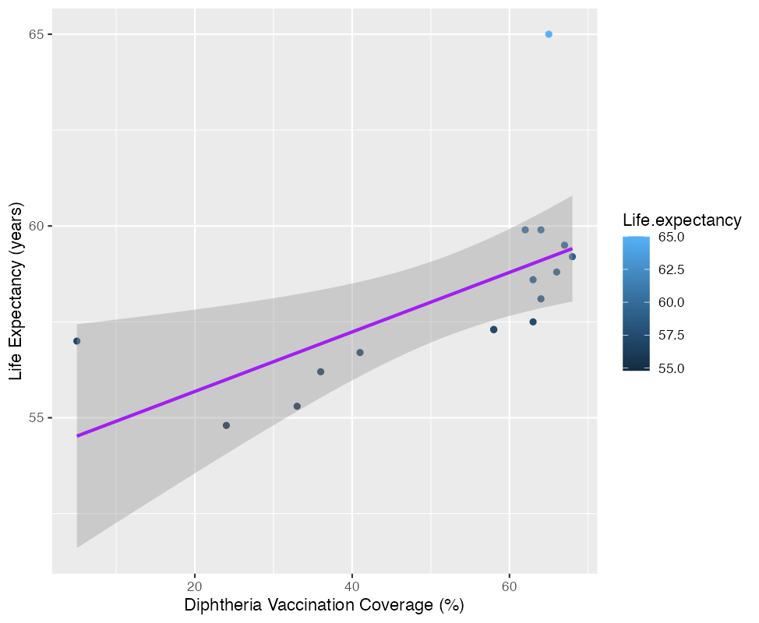

GDP vs Life Expectancy

